**A**

**PROJECT REPORT**

**ON**

**SATELLITE IMAGE SEGMENTATION**

Submitted in partial fulfillment

for the award of the degree of

Bachelor of Technology

In

**Information Technology**

**(BIKANER TECHNICAL UNIVERSITY, BIKANER)**



**SESSION (2022-23)**

**SUBMITTED TO: SUBMITTED BY:**

Mrs. Meeta Sharma Riya Soni

HOD Of CE 19EEMIT010

Seema Gehlot

19EEMIT011

**Department of Computer Engineering**

**Govt. Women Engineering College, Ajmer**

**Bikaner Technical University, Bikaner**

**TABLE OF CONTENTS**

|  |  |  |
| --- | --- | --- |
| **CHAPTER NO.** | **TITLE** | **PAGE NO.** |
|  | **CERTIFICATE** |  |
|  | **ACKNOWLEDGMENT** |  |
|  | **ABSTRACT** | **1** |
| **1.** | **INTRODUCTION** |  |
|  | 1.1 Image Augmentation |  |
|  | 1.2 Semantic Segmentation |  |
|  | 1.3 Evaluation |  |
|  | 1.4 Motivation |  |
|  | 1.5 Problem Statement |  |
|  | 1.6 Requirements |  |
| **2.** | **PROBLEM STATEMENT** |  |
|  | 2.1 Detail |  |
|  | 2.2 Dataset |  |
|  | 2.3 Solution |  |
|  | 2.4 Workflow |  |
| **3.** | **METHODOLOGY** |  |
|  | 3.1 Pre-processing |  |
|  | 3.1.1 Getting Dataset |  |
|  | 3.1.2 Importing Libraries |  |
|  | 3.1.3 Importing Dataset |  |
|  | 3.1.4 Image Augmentation |  |
|  | 3.1.5 Replacing HEX values with RGB |  |
|  | 3.1.6 Replacing RGB values with  Labels from 0 to 5 |  |
|  | 3.2 Training Model |  |
|  | 3.2.1 Train Test Split |  |
|  | 3.2.2 Model Parameters |  |
|  | 3.2.3 Defining Model |  |
|  | 3.2.4 Building Model using different  Optimizers |  |
| **4.** | **IMAGE AUGMENTATION** |  |
|  | 4.1 Augmentation using Geometric Techniques |  |
|  | 4.2 Augmentation using GANs |  |
| **5.** | **TRAINING OF MODEL** |  |
| **6.** | **TESTING OF MODEL** |  |
|  | **CONCLUSION** |  |
|  | **REFERENCES** |  |
|  |  |  |

|  |  |
| --- | --- |
|  | **MAHILA ENGINEERING COLLEGE, AJMER**  **(An Autonomous Institute of Govt. of Rajasthan)**  **Nasirabad Road, Makhupura, Ajmer – 305002** |

**CERTIFICATE**

This is to certify that the Project Report entitle **“Satellite Image Segmentation using U-Net”** has been submitted by Ms. Riya Soni and Ms. Seema Gehlot in partial fulfillment for the requirement of the degree of Bachelor of Technology in Information Technology for the academic Session 2022-23.

She has been undergone the requisite work as prescribed by Bikaner Technical University, Bikaner.

(Dr. Varun Prakash Saxena) (Ms Meeta Sharma)

Asst. Professor of CSE HOD

Department of CE

Place :- GOVT. WOMEN ENGINEERING COLLEGE , AJMER

Date :- 22th May, 2023

**ACKNOWLEDGEMENT**

I feel profound happiness in forwarding this project as an image of sincere efforts. It is almost inevitable to ensure indebtedness to all who generously helped by sharing their valuable experience and devoting their precious time with us, without whom this project report would have never been accomplished.

First & foremost I extend my thanks & gratitude to my guide **Dr. Varun Prakash Saxena**, whose guidance, teaching, and invaluable suggestions provided me a deep insight in my chosen field of technology, enhanced my knowledge and supported in widening my outlook towards the trends in technology.

I am highly indebted to our project coordinator **Pankaj Kr. Sharma** for providing me the desired platform and delivering the learning in an effective and efficient manner.

**Yours Sincerely**

Riya Soni

Seema Gehlot

**ABSTRACT**

Image segmentation is the process of partitioning, or segmenting, a digital image into multiple Smaller segments. The goal of image segmentation is to simplify and transform the representation of an image into a format that is more meaningful to a computer and thus, easier to analyze. However, segmentation algorithms are challenged with many difficulties such as: uneven illumination, noise, and presence of foreign objects.

The aim of this project was to explore and present an optimal and efficient image segmentation method based on image processing algorithms learned throughout the course. Various types of images are used in the study. The segmentation process would have to efficiently isolate the foreground from the background and any other foreign objects present in the original image. Several algorithms can be used to fulfill the purpose. For image segmentation using CNN (Convolutional Neural Network), there are many models which are used for image semantic segmentation for example- SegNet, DenseNet, E-Net, Link-Net, Mask RCNN, PSP-Net, RefineNet etc.. In this case, **U-Ne**t has been chosen which is basically a convolutional auto-encoder and the advantage is that spatial dimensions of input data for training and inference need not be the same. It does not need much of the training data to get trained. So, it is most of the choice when working with satellite imagery data. and finally, Jupyter Notebook and Python scripts were used to serve the purpose.

**CHAPTER 1**

**INTRODUCTION**

Image segmentation is a broad and active field of research in areas such as computer vision, satellite imagery and medical field. Its purpose is to divide an image into regions which are meaningful for a particular task. Various methods and approaches are used; the choice of a particular method depends on the characteristics of the problem to be solved and its place in a wider image analysis strategy. Segmentation is an essential step prior to the description, recognition or classification of an image or its constituents. In other words, the goal of image segmentation is to group pixels together based on certain characteristics that could be its color, shape, size, etc.

The object detection in satellite imagery is a primary goal and elaborate one receiving a lot of interest in recent years and performs an essential function for a wide range of applications. After the massive fulfillment of Deep learning techniques in computer imaginative and prescient discipline, they're presently being studied in the context of satellite imagery for unique functions like object identification, object tracking, object classification, semantic segmentation of aerial/satellite images. Although diverse assessment research associated with object detection from satellite/aerial imagery is carried out, this observation provides an assessment of the latest development in the discipline of object detection from satellite imagery with the use of deep learning.

**1.1 IMAGE AUGMENTATION**

Image augmentation is a technique that is used to artificially expand the data-set. This is helpful when we are given a data-set with very few data samples. In the case of Deep Learning, this situation is bad as the model tends to over-fit when we train it on a limited number of data samples.

The dataset consists of aerial imagery of Dubai obtained by MBRSC satellites and annotated with pixel-wise semantic segmentation in 6 classes. The total volume of the dataset is 72 images grouped into 6 larger tiles: Buildings, Roads, Land, Water bodies, Vegetation and Unlabelled. In order to avoid the overfitting we have expanded our dataset using Image Augmentation. Our dataset have 8 tiles each having 9 images and their associated masks. The size of images in individual tiles is the same but the size of an image in a tile is different from the size of image of another tile. So to figure out this issue we have cropped them to a nearest size divisible by 256 and then divide all images into patches of 256x256x3.

**1.2 SEMANTIC SEGMENTATION**

Semantic segmentation is a deep learning algorithm that associates a label or category with every pixel in an image. It is used to recognize a collection of pixels that form distinct categories. It is the ability for a machine to classify features in a given image pixel-by-pixel to create a mask. The goal for this project is to input these masks into a feature detector to determine significant features in an image. A U-Net architecture is utilized to perform this semantic segmentation since it is the best performing method for aerial imagery.

U-Net is an architecture for semantic segmentation. It consists of a contracting path and an expansive path. The contracting path follows the typical architecture of a convolutional network. It was originally invented and first used for biomedical image segmentation. Its architecture can be broadly thought of as an encoder network followed by a decoder network.We have trained our model using three different optimizers: Adam, Adamax and RMSprop, to compare their results with evaluation parameters.

**1.3 EVALUATION**

The evaluation matrices used during training are binary accuracy and mIoU. The weights of the models with the lowest validation loss and high mIoU scores are used since these models are more likely to perform the best when predicting the final test set and because mIoU is more commonly used for semantic segmentation. The loss functions used for these experiments were the mIoU approximation and binary cross-entropy. The mIoU approximation, also known as Jaccard loss, was implemented since the evaluation metrics for most of the datasets as well as many others in semantic segmentation use mIoU as a standard.

**1.4 MOTIVATION**

Satellite images are one of the most powerful and important tools we have for monitoring the earth. They track the physical environment (water, air, land, vegetation) and the changing human footprint across the globe. Satellite imagery is used to measure, identify and track human activity. Apart from this it is also used in Archaeological department to study the land on the basis of these parameters: in different seasons, over different timestamps, soil type, etc; in order to determine whether this land can be an archaeological site for research or not

**1.5 PROBLEM STATEMENT**

With the set of images and prior knowledge about the content of the images, we have to find the correct Symantec label for the pixels in the image. Labels are: Buildings, Roads, Land, Water Bodies, Vegetation, and Unlabeled. We need to go through the cycle of segmentation, feature extraction, testing, and validation.

**1.6 REQUIREMENTS**

Functional requirements are the high level system requirements for the above problem statement. Our functional requirements are as follows:

* Software- Jupyter Notebook 6.5.4
* Processor- GPU
* Programming Language- Python 3.10.11
* Modules and Frameworks- Tensorflow 2.12.0, Keras 3.7.2, OpenCv 4.7.0, Patchify 0.2.3,

Segmentation Models 1.0.1, Numpy 1.24, Matplotlib 3.7.1,

Sklearn 0.23.0

* Algorithm- U-Net
* Optimizers- Adam, Adamax, RMSprop

**CHAPTER 2**

**PROBLEM STATEMENT**

**2.1 DETAIL**

Image segmentation is one of the important trends in image processing. It is a technique which divides or partitions an image into segments. There are various application areas for image segmentation mostly are image compression, medical applications, satellite imagery, object recognition etc.. as it is not efficient to process the entire image. Image segmentation segments an image into sub regions of our interest and then those areas can be analyzed individually. There are many techniques for this which partition an image into segments based on certain features like color, texture, pixel intensity etc... and the categorization of techniques are done based on the method used. Here in this case, the problem statement is that the images received from satellite will be segmented and then roads, buildings, land, vegetation, etc. present in the image need to be detected.

**2.2 DATASET**

The dataset consists of aerial imagery of Dubai obtained by MBRSC satellites and annotated with pixel-wise semantic segmentation in 6 classes. The total volume of the dataset is 72 images grouped into 6 classes. The classes are:

1. Building: #3C1098
2. Land (unpaved area): #8429F6
3. Road: #6EC1E4
4. Vegetation: #FEDD3A
5. Water: #E2A929
6. Unlabeled: #9B9B9B

There are a total of 8 tiles in the directory, each tile having 9 images and their masks. The size of any image is the same with respect to the images of that particular tile, but the size of images present in different tiles have different sizes.

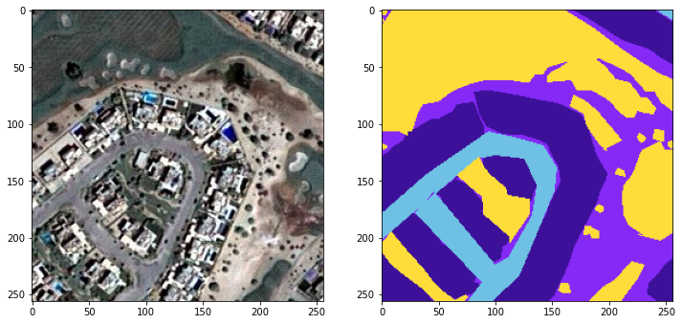

Figure 2.1 Satellite image with its Mask

**2.3 SOLUTION**

For image segmentation using CNN (Convolutional Neural Network), there are many models which are used for image semantic segmentation for example- SegNet, it is an architecture for image segmentation based on deep convolutional encoder-decoder. Fully Convolutional DenseNet, this is for semantic segmentation, The One Hundred Layers Tiramisu is an example of it. The other more are E-Net for real-time semantic segmentation and Link-Net, for efficient semantic segmentation it exploits the encoder representations. Few more names like Mask RCNN, PSP-Net, RefineNet etc.. In this case, **U-Ne**t has been chosen which is basically a convolutional auto-encoder and the advantage is that spatial dimensions of input data for training and inference need not be the same. It does not need much of the training data to get trained. So, it is most of the choice when working with satellite imagery data.

**2.4 WORKFLOW**

* Importing Libraries
* Image Processing  
  1) Getting Dataset  
  2) Importing Libraries  
  3) Importing Dataset  
  4) Image Augmentation  
  5) Replacing HEX values with RGB  
  6) Replacing RGB values with Labels from 0 to 5
* Model Building  
  1) Train Test Split  
  2) Model Parameters  
  3) Defining Model  
  4) Building Model using different Optimizers
* Model Testing

**CHAPTER 3**

**METHODOLOGY**

**3.1 PRE-PROCESSING**

Preprocessing of data is performed to ensure that it is in a format that the network can accept is a common first step in deep learning workflows. For example, you can resize image input to match the size of an image input layer. You can also preprocess data to enhance desired features or reduce artifacts that can bias the network.

Steps involved for pre processing in this project are:

1) Getting Dataset  
2) Importing Libraries  
3) Importing Dataset  
4) Image Augmentation  
5) Replacing HEX values with RGB  
6) Replacing RGB values with Labels from 0 to 5

**3.3.1 Getting Dataset:** To create a machine learning model, the first thing we required is a dataset as a machine learning model completely works on data. The collected data for a particular problem in a proper format is known as the **dataset**.

**3.1.2 Importing Libraries:** In order to perform data pre-processing using Python, we need to import some predefined Python libraries. These libraries are used to perform some specific jobs. There are three specific libraries that we have used for data preprocessing, which are:

* **Numpy:** Numpy Python library is used for including any type of mathematical operation in the code. It is the fundamental package for scientific calculation in Python. It also supports to add large, multidimensional arrays and matrices.

To import - import numpy is np

* **OS:** Python OS module provides the facility to establish the interaction between the user and the operating system. It offers many useful OS functions that are used to perform OS-based tasks and get related information about operating systems.

To import - import os

* **OpenCv:** OpenCV is a Python library that allows you to perform image processing and computer vision tasks. It provides a wide range of features, including object detection, face recognition, and tracking.

To import - import cv2

* **Matplotlib:** The second library is **matplotlib**, which is a Python 2D plotting library, and with this library, we need to import a sub-library **pyplot**. This library is used to plot any type of charts in Python for the code.

To import - from matplotlib import pyplot as plt

* **Patchify:** It is used to split images into small overlappable patches by given patch cell size, and merge patches into the original image. This library provides two functions: patchify, unpatchify.

To import - from patchify import patchify

* **Segmentation Models:** Segmentation models is a python library with Neural Networks for Image Segmentation based on Keras (Tensorflow) framework. The main features of this library are: High level API (just two lines to create NN) 4 models architectures for binary and multi class segmentation (including legendary U-Net)

To import - import segmentation_models as sm

* **Tensorflow:** The TensorFlow platform helps you implement best practices for data automation, model tracking, performance monitoring, and model retraining. Here we need to import MeanIoU from this module of python.

To import - from tensorflow.keras.metrics import MeanIoU

**3.1.3 Importing Dataset:** Now we need to import the datasets which we have collected for our machine learning project. And to load the dataset we need the help of the os library.

**3.1.4 Image Augmentation:**  Image Augmentation is a technique that is used to artificially expand the data-set.

The size of our dataset is 32MB, it consists of only 72 images and their masks. To gain better results and avoid overfitting we need to expand our dataset. In order to do that we need to use Image Augmentation technique.

The other reason to crop images instead of resizing is to keep the sizes of objects as it is. As the size of images in a tile is different from the size of image of another tile, we have cropped them to a nearest size divisible by 256 and then divide all images into patches of 256x256x3.

**3.1.5 Replacing HEX values with RGB:** Now to move forward we need to convert the HEX values of labels into RGB values

**3.1.6 Replacing RGB values with Labels from 0 to 5:** We are now converting our RGB labels into categorical values labeling them from 0 to 5.

**3.2 TRAINING MODEL**

Training a model simply means learning (determining) good values for all the weights and the bias from labeled examples. In supervised learning, a machine learning algorithm builds a model by examining many examples and attempting to find a model that minimizes loss; this process is called empirical risk minimization.

Steps involved in Training the model are as follows:

1) Train Test Split  
2) Model Parameters  
3) Defining Model  
4) Building Model using different Optimizers

**3.2.1 Train Test Split:** It is a method to measure the accuracy of the model. It is used to split the data set into two sets: a training set and a testing set. 80% for training, and 20% for testing. We train the model using the training set.

**3.2.2 Model Parameters:** The parameters used for the model are as follows:

* **Weights:** Weights refer to connection managements between two basic units within a neural network. To train these units to move forward in the network, weights of unit signals must be increased or decreased.
* **Dice Loss:** It is widely used in image segmentation tasks to address the data imbalance problem.

To define dice loss - dice_loss = sm.losses.DiceLoss(class_weights=weights)

* **Focal Loss:** It is an extension of the cross-entropy loss function that would down-weight easy examples and focus training on hard negatives.

To define focal loss - focal_loss = sm.losses.CategoricalFocalLoss()

* **Total Loss:** It is the sum of Dice Loss and Focal Loss.

It can be defined as - total_loss = dice_loss + (1 * focal_loss)

**3.2.3 Defining Model:** UNET is a U-shaped encoder-decoder network architecture, which consists of four encoder blocks and four decoder blocks that are connected via a bridge. The encoder network (contracting path) half the spatial dimensions and double the number of filters (feature channels) at each encoder block. Figure 3.1 and Figure 3.2 shows the architectural representation of U-Net.

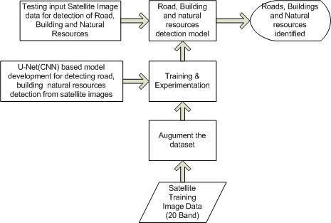

Figure 3.1 Architecture of U-Net model

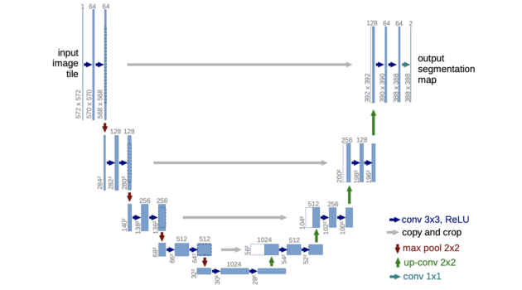

Figure 3.2 U-shaped Architecture of U-Net

**3.2.4 Building Model using different Optimizers:** In this model we have used three optimizers:

* **Adam-** Adam optimization is a stochastic gradient descent method that is based on adaptive estimation of first-order and second-order moments.
* **Adamax-** Adamax, a variant of Adam based on the infinity norm, is a first-order gradient-based optimization method. Due to its capability of adjusting the learning rate based on data characteristics, it is suited to learn time-variant process
* **RMSprop-** The RMSprop optimizer is similar to the gradient descent algorithm with momentum. The RMSprop optimizer restricts the oscillations in the vertical direction. Therefore, we can increase our learning rate and our algorithm could take larger steps in the horizontal direction converging faster.

**CHAPTER 4**

**IMAGE AUGMENTATION**

Image augmentationis atechnique that is used to artificially expand the data-set. This is helpful when we are given a data-set with very few data samples. In the case of Deep Learning, this situation is bad as the model tends to over-fit when we train it on a limited number of data samples.

Image augmentation parameters that are generally used to increase the data sample count are zoom, shear, rotation, preprocessing_function and so on. Usage of these parameters results in generation of images having these attributes during training of Deep Learning models. Image samples generated using image augmentation, in general, result in increase of existing data sample set by nearly 3x to 4x times.

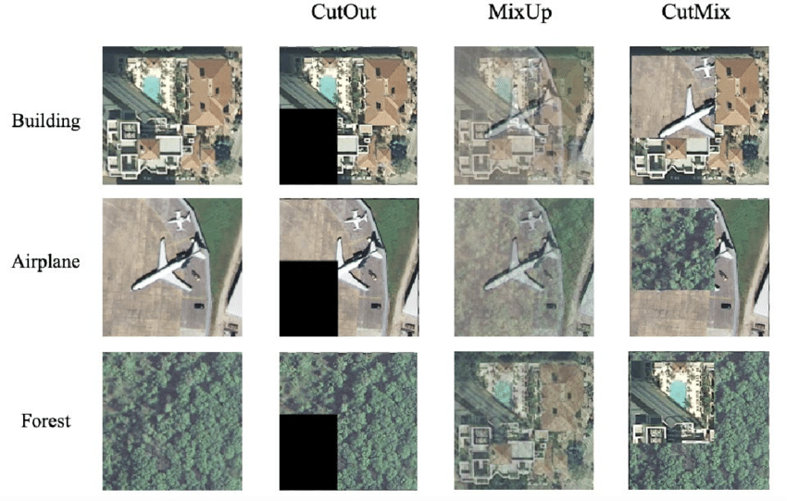

Figure 4.1 An example to demonstrate how image augmentation works

In figure 4.1 we saw how a single image can be augmented using image augmentation. This helps when the size of the dataset is less. Training a model on a very small dataset may lead to poor performance when applied to a new, never-seen-before dataset. Augmentation techniques such as random flipping, rotation, zooming and channel averaging have been successfully applied to RGB images; however these techniques are limited when applied to satellite imagery and might not have a significant impact as a result of inherent uniformity in the images, as also reported by [1]. Despite the unique challenges associated with training deep learning models with images, it is widely accepted that data augmentation can lead to significant improvements in the performance of these models by making them more robust to noise and less likely to overfit.

Techniques used for data augmentation are as follows:

**4.1 AUGMENTATION USING GEOMETRIC TECHNIQUES**

Data augmentation increases the amount of data available to train a model. The primary advantage of doing this is that it makes the model more robust and less susceptible to overfitting. In addition, it can improve the model performance by mimicking the image with different features. Different augmentation techniques have been shown to improve the model performance differently, depending on the quantity and quality of these features. Small satellite image datasets have been used for training deep learning models in existing works. **Horizontal and vertical flipping** had the highest accuracy out of the techniques considered for classifying satellite images. Image zooming or scale augmentation was used when the image is zoomed in or out, depending on a rate magnitude. **Rotation augmentation** is another relevant technique in which several copies of an image are produced by rotating it through different angles. Furthermore, the authors in [8] used flip, translation and rotation in remote sensing scene classification. However, [9] concluded that geometric transformations like rotation, zooming and translation have limited use for medium and low-resolution satellite data as they do not provide enough variability. Existing literature in the domain of remote sensing has used multi-temporal satellite data for both classification and semantic segmentation. [10] shows that combining images from several years from the same sensor on a single location improves model performance. With multi-temporal data, [11] found the best date of observation based on available data. The authors in [12] combined images from different dates by taking a weighted average of the spectral values. [13] proposed channel dropout as a means of reducing overfitting of a CNN model trained on RGB images. The technique involved setting the pixel value of a channel with some predefined probability to zero. Color Jittering is another data augmentation technique that has been successfully applied to RGB images. Here, the pixel values in each channel are multiplied by some random number within a fixed range. The technique can be used to augment an RGB image dataset. Mix Channel approach is also being used, where a channel from the original image is replaced with the same channel of another image of the same location on a different date, outperformed state of the art models. Mix Channel approach showed better generalizability compared to generic data augmentation techniques like color jittering and geometric transformations.

**4.2 AUGMENTATION WITH GANs:**

Generative Adversarial Networks (GANs) have also been used for data augmentation on traditional RGB images and Satellite images. This is an unsupervised way of generating data. The generative model usually comprises the generator and discriminator, which work like gaming components. The former learns to generate realistic images and trick the discriminator which attempts to differentiate between the real and synthesized images. Examples of GANs, which have been applied to satellite images are DCGAN, CycleGAN, SSSGAN. High resolution images can be generated using a progressive growing GAN. GANs can be applied to satellite images for both image generation and image style transfer with visually promising results. Conditional GAN can also be applied to satellite images.